ANIMAL MOBILE PINK GIRL
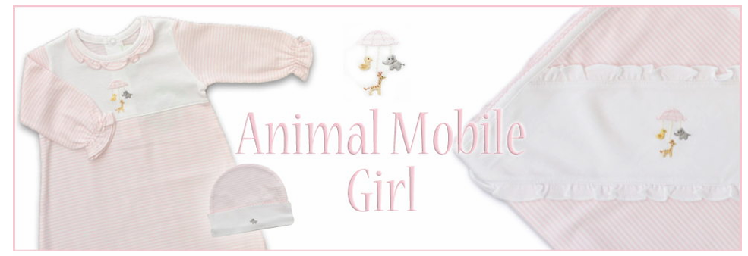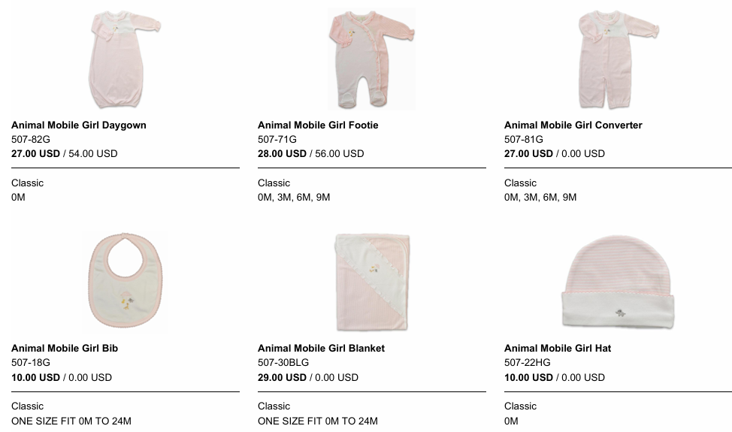
ANIMAL MOBILE BLUE BOY
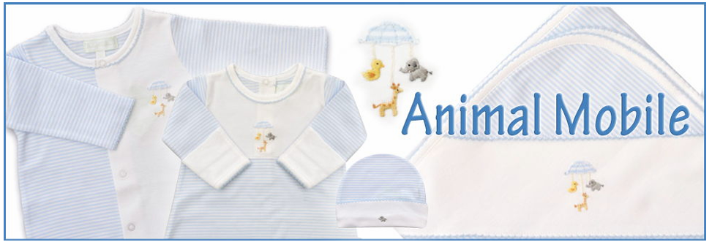
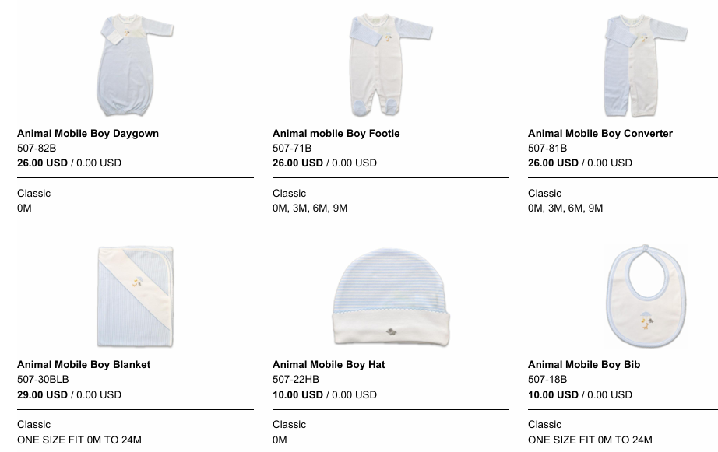
ARGYLE SMOCKED BLUE
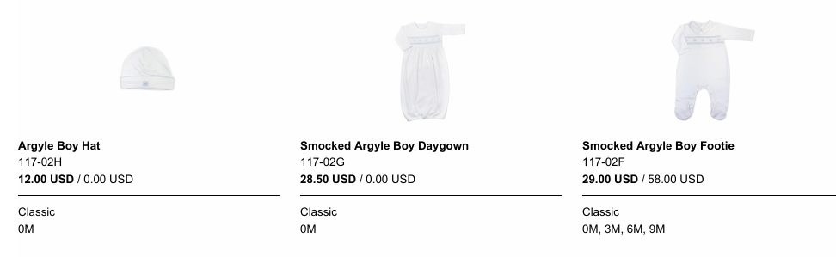
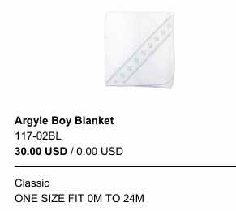
BABY SAFARI
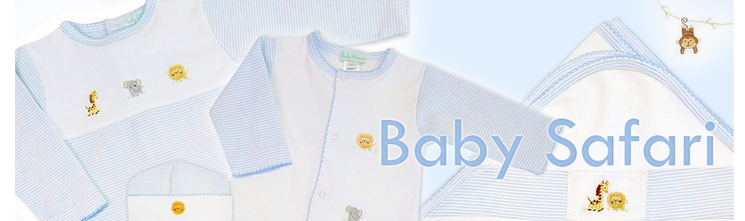
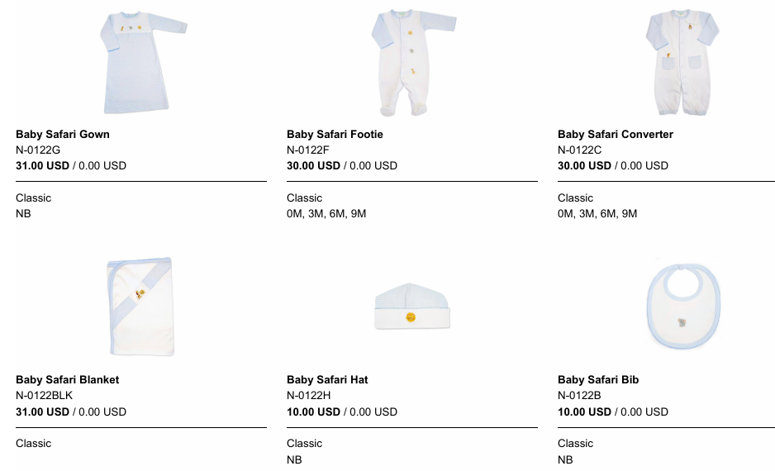
BOWS
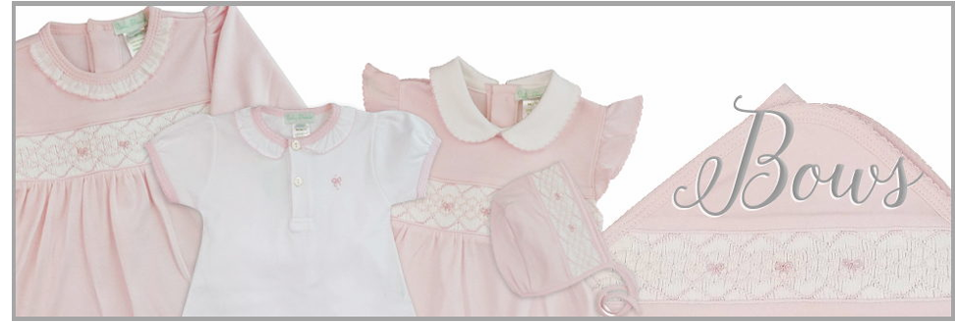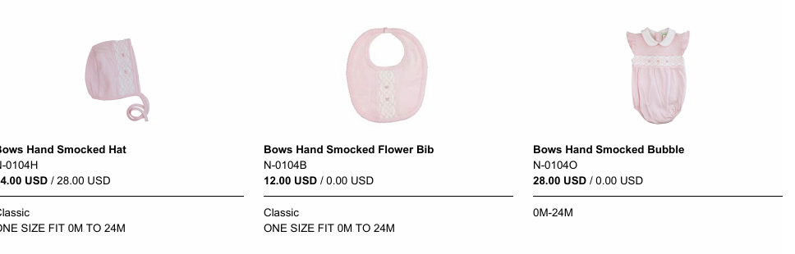

…. CONTINUED..

…. BOWS CONTINUED..

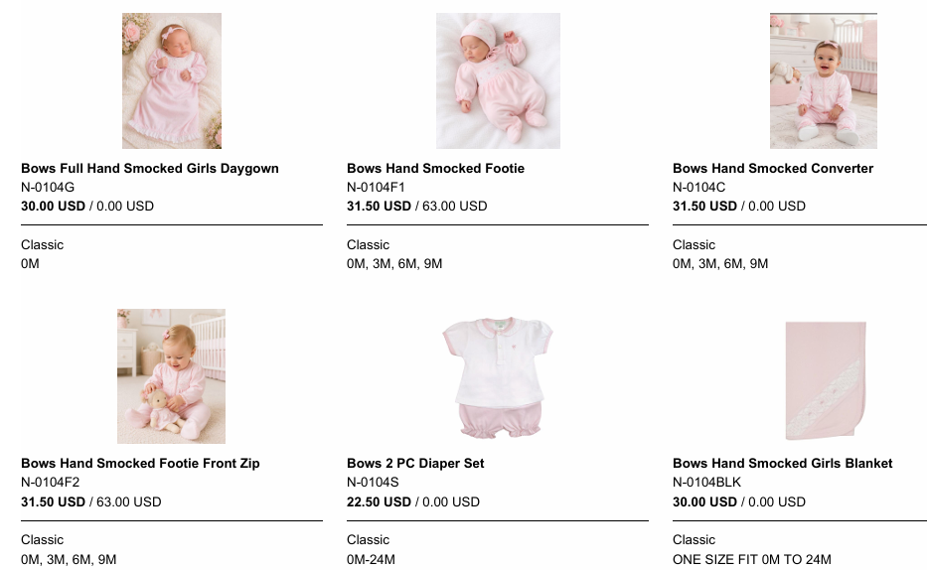

BOW CROCHET
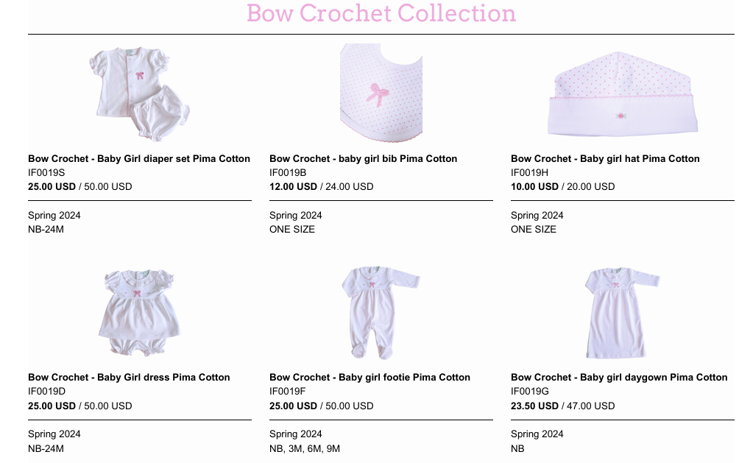
… CONTINUED…

… BOW CROCHET CONTINUED
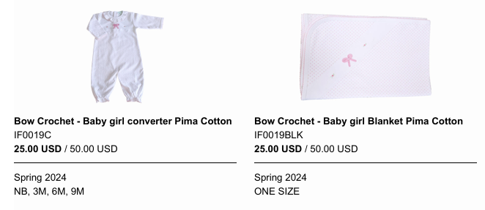

BRIELE
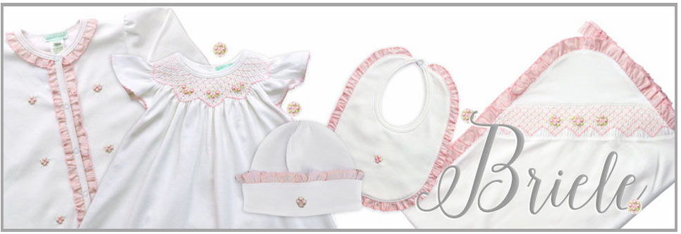
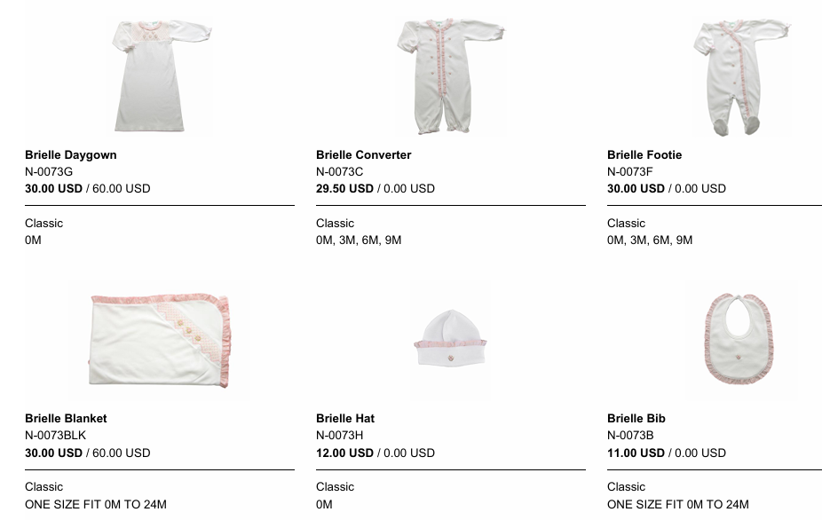
CARS
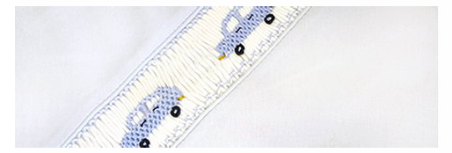
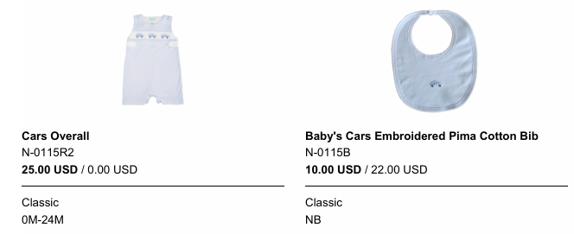
… CONTINUED…
…. CARS CONTINUED
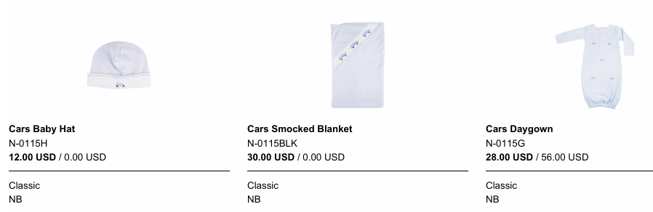
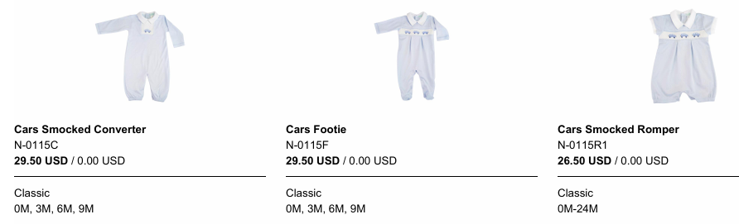

CELINE BOYS COLLECTION
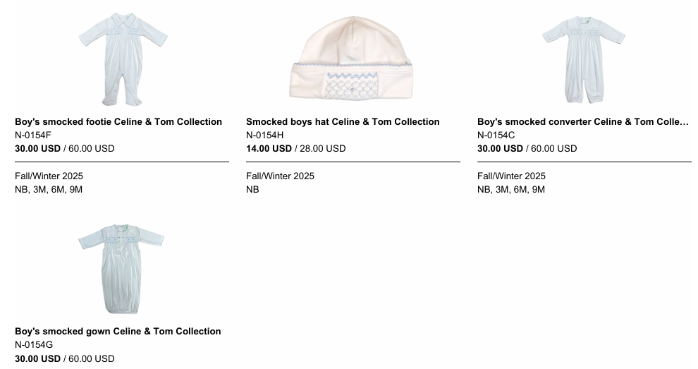
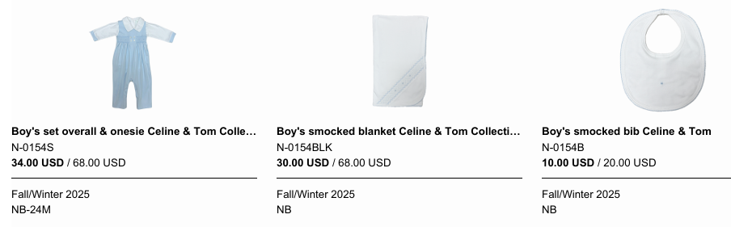
CELINE GIRLS COLLECTION
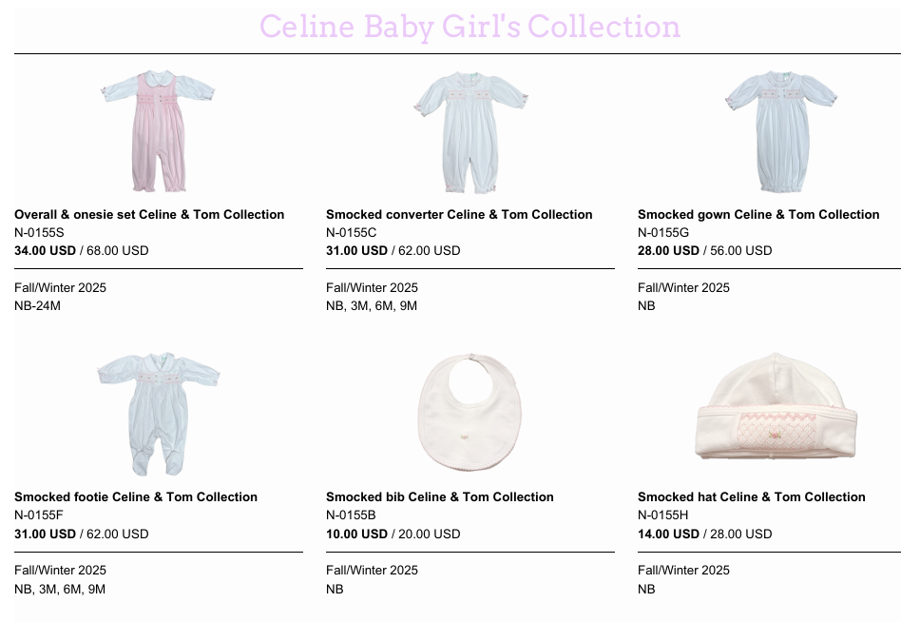
*** ALSO BLANKET - N-0155BLK $30
CHECKS FOR MONOGRAM – BLUE
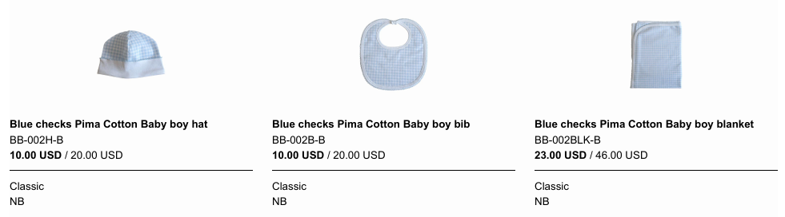
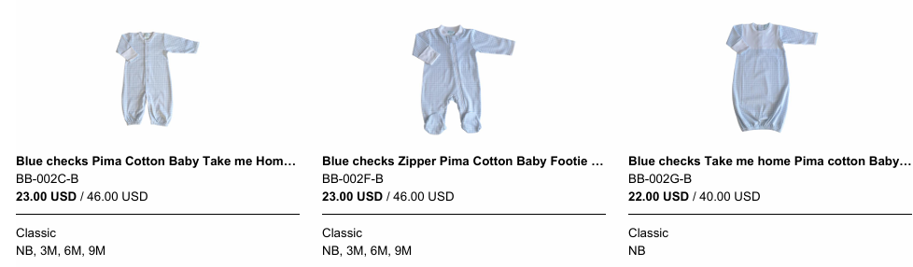

CHECKS FOR MONOGRAM – PINK
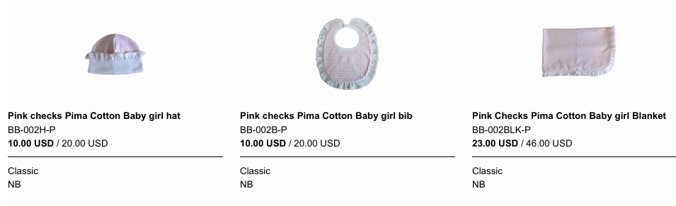
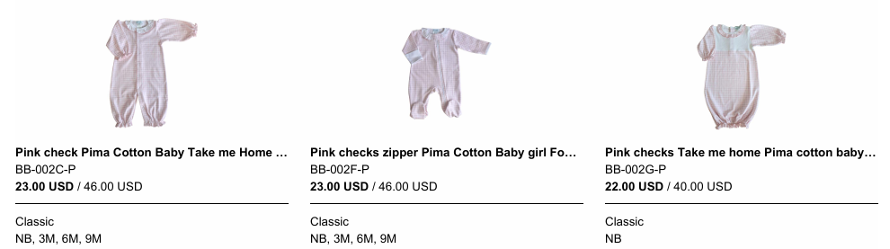

CLASSIC BLUE SMOCKED COLLECTION
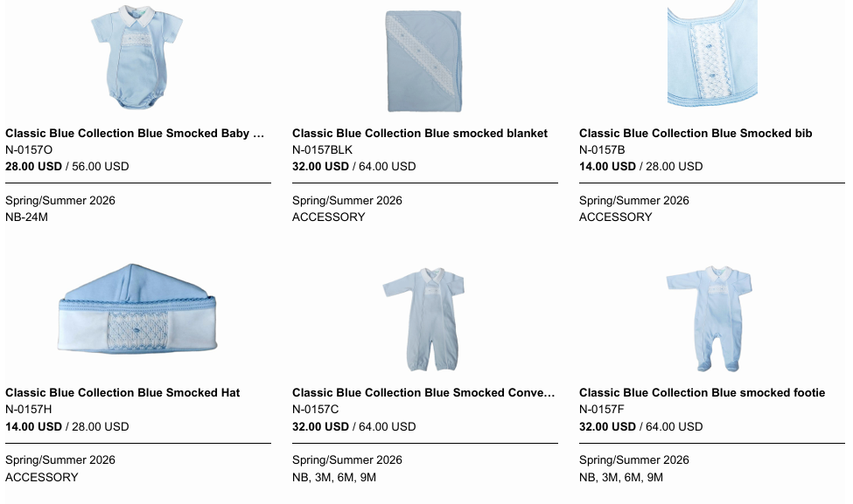
*** ALSO DAYGOWN - N-0157G 30.00 USD

CLASSIC PINK SMOCKED COLLECTION
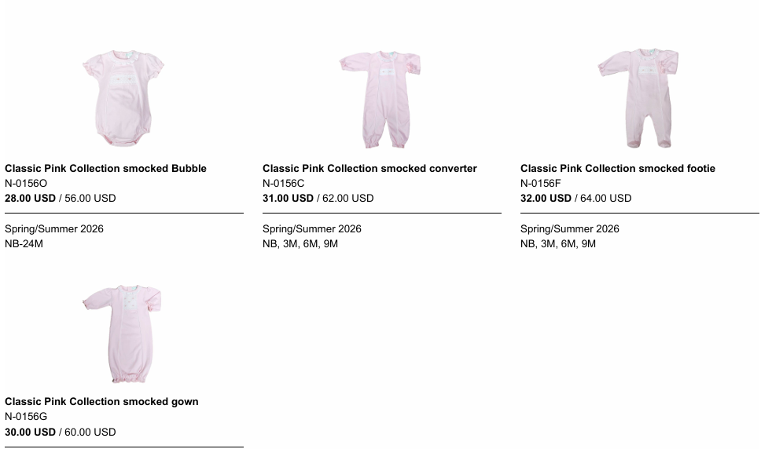
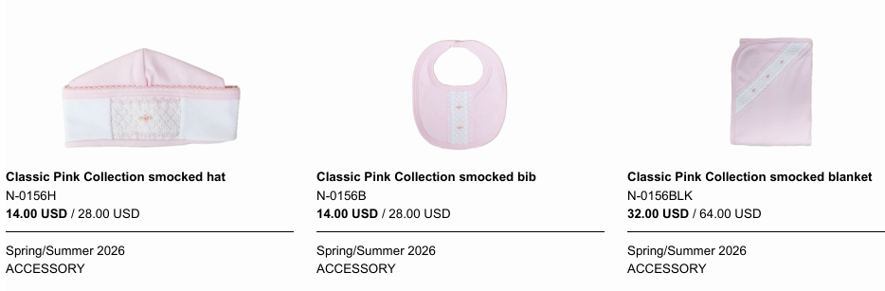
CROSSES – BLUE BOY

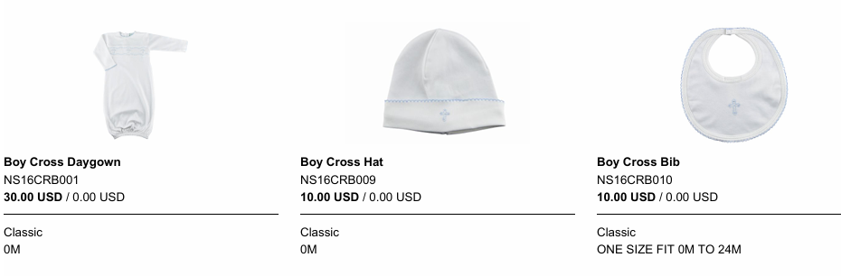
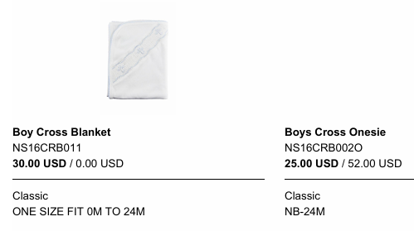
CROSSES – PINK GIRL
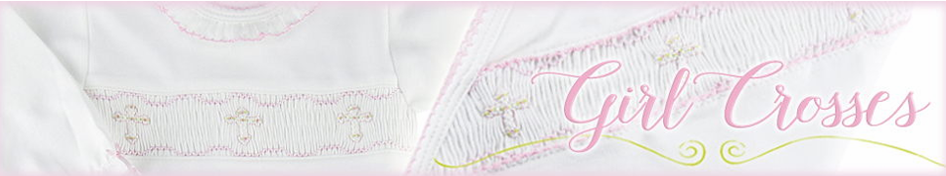
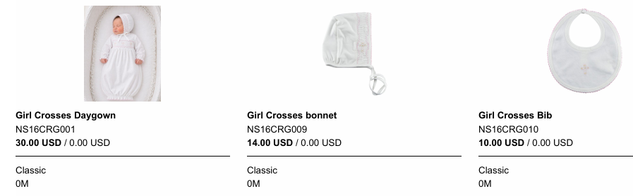
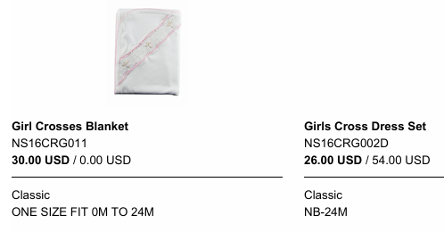
CUTE GIRAFFE
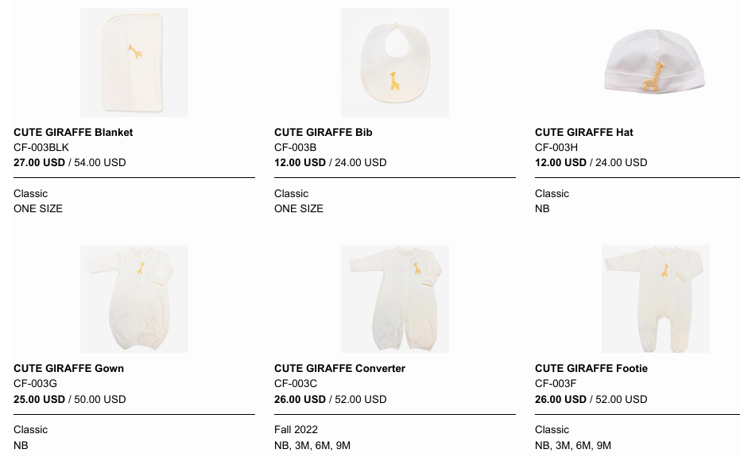

DUCKIES
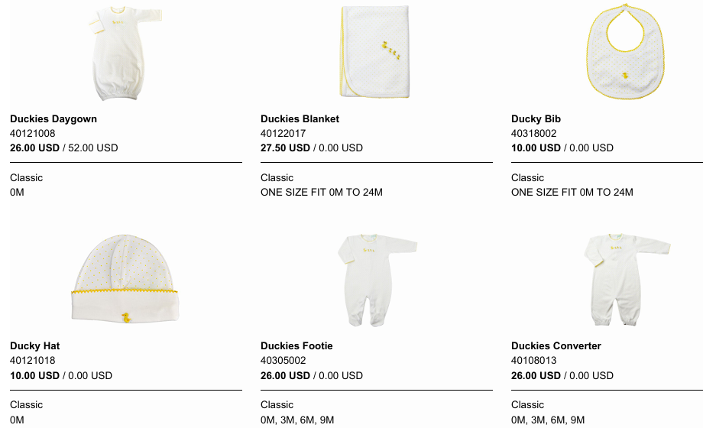

EDEN BOYS BLUE
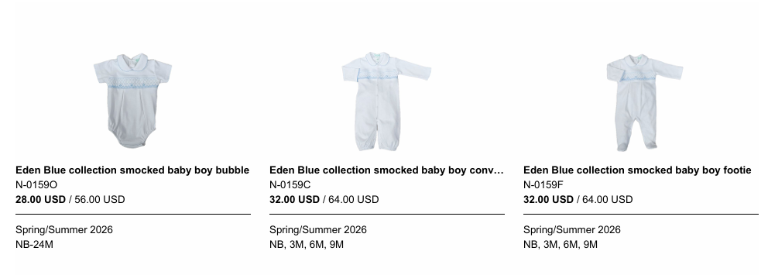
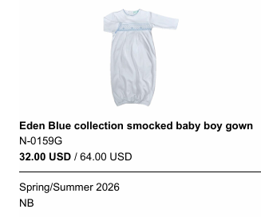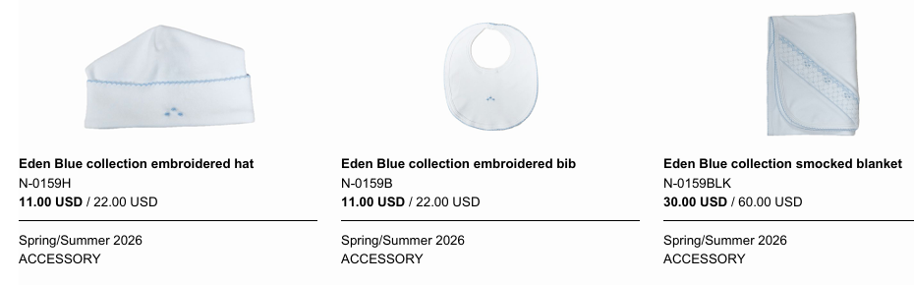

EDEN ROSEBUD WHITE WITH PINK GIRL
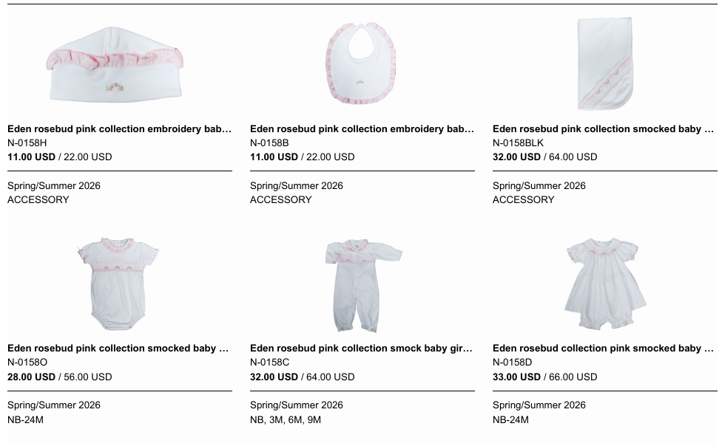
…. CONTINUED..
… EDEN ROSEBUD WHITE WITH PINK CONTINUED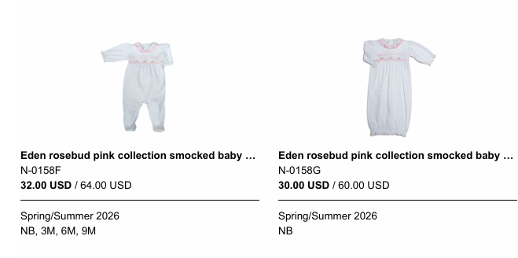

ELEPHANT BLUE BOYS
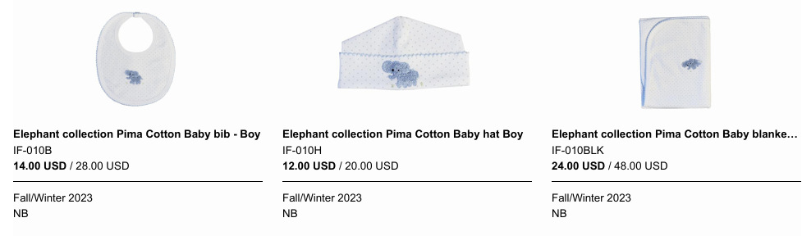
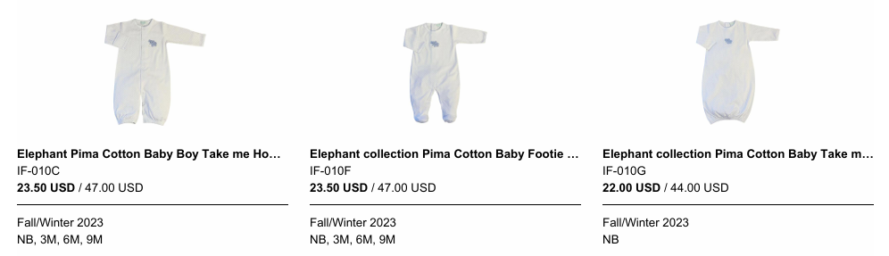

ELEPHANT PINK GIRL
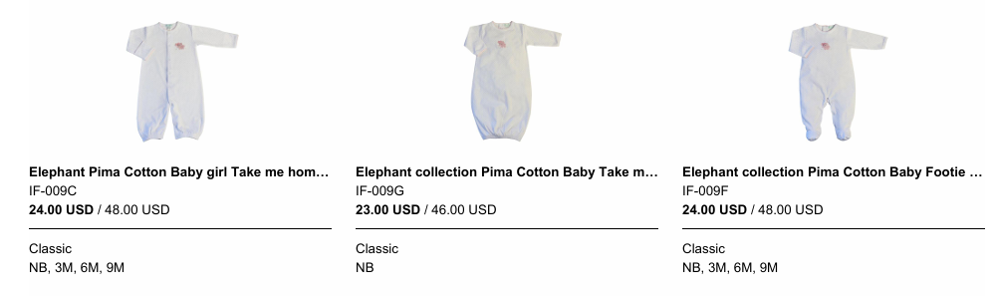
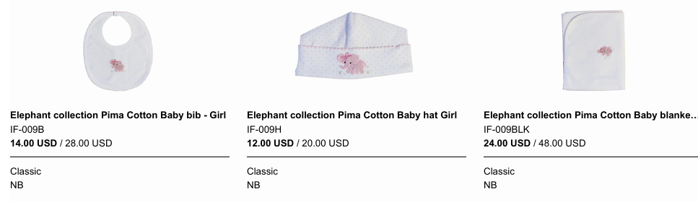

ENGLISH ROSES
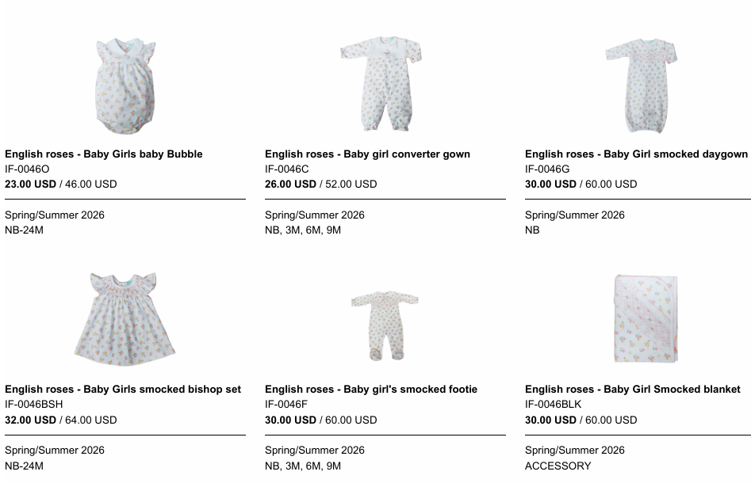
….. CONTINUED..
… ENGLISH ROSES CONTINUED
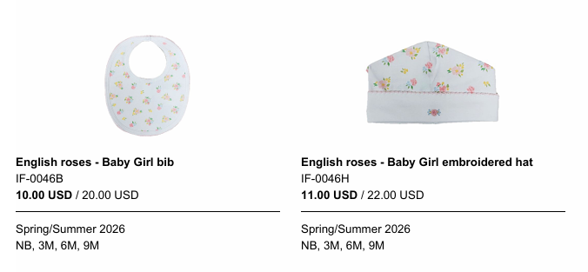

FEATHERS AND ROSE BUDS WHITE
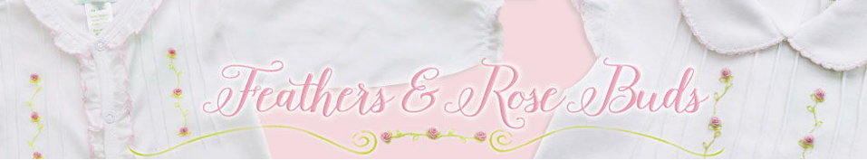
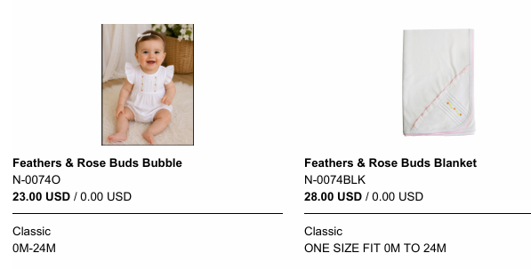
…. CONTINUED….

……… FEATHERS AND ROSE BUDS WHITE CONTINUED…
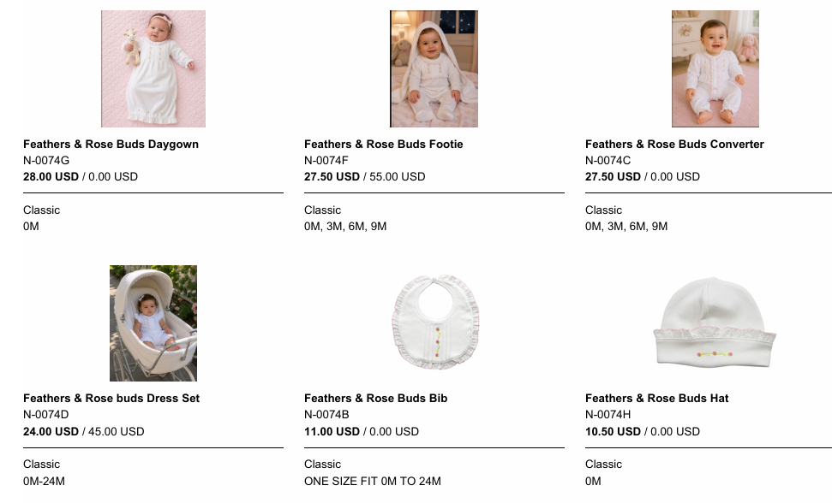

FEATHERS AND ROSE BUDS PINK
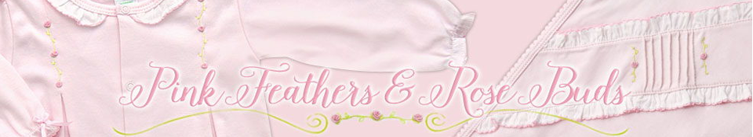
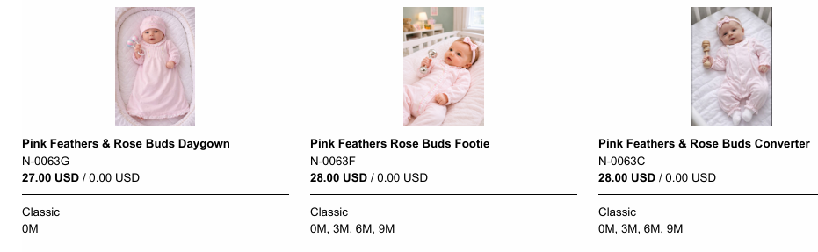
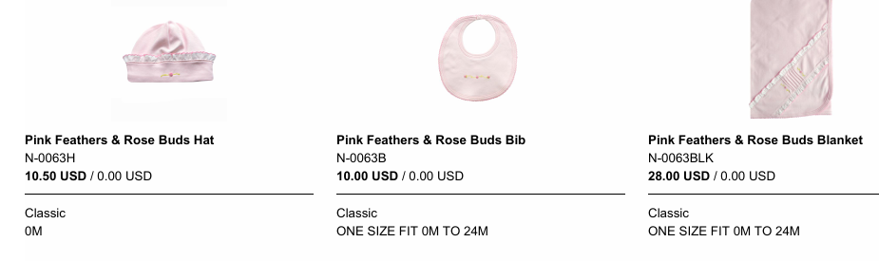
FLOWER BOUQUETS
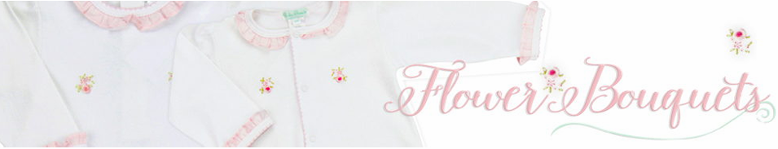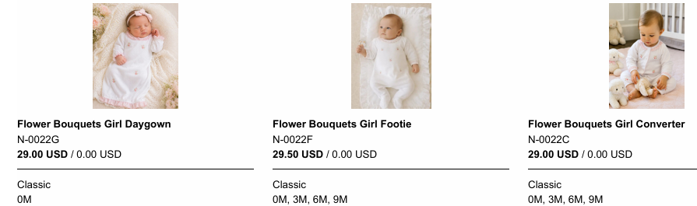
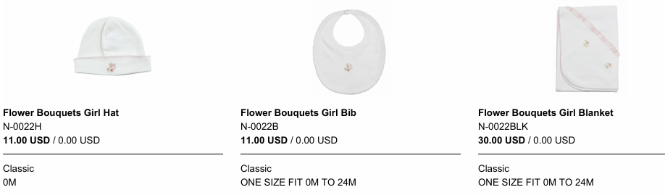
FLOWERS SMOCKED
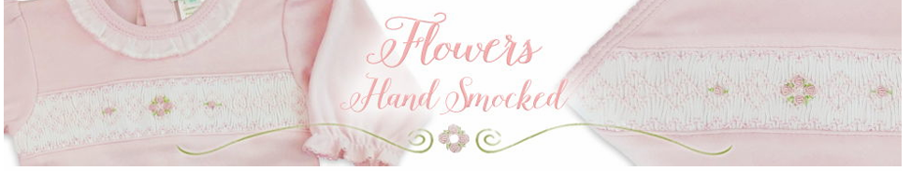
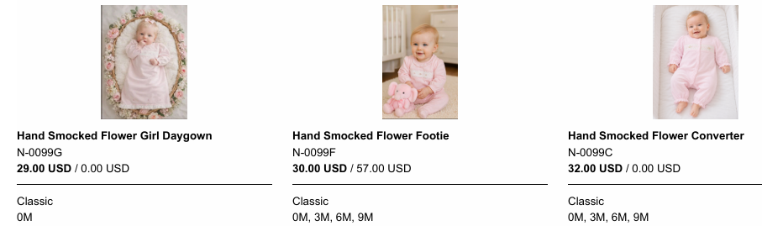
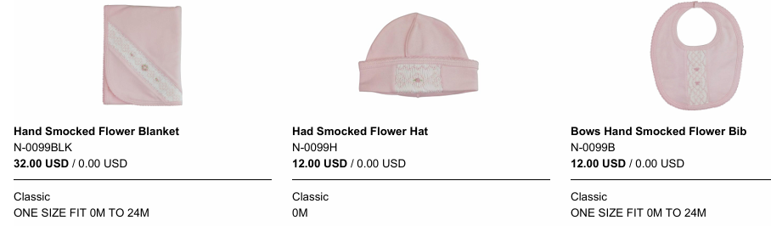
HAND SMOCKED BOYS BLUE
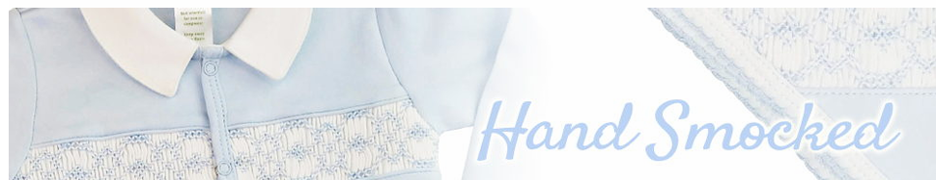
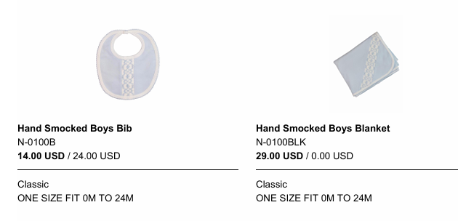
…. CONTINUED…
…. HAND SMOCKED BOYS BLUE CONTINUED..
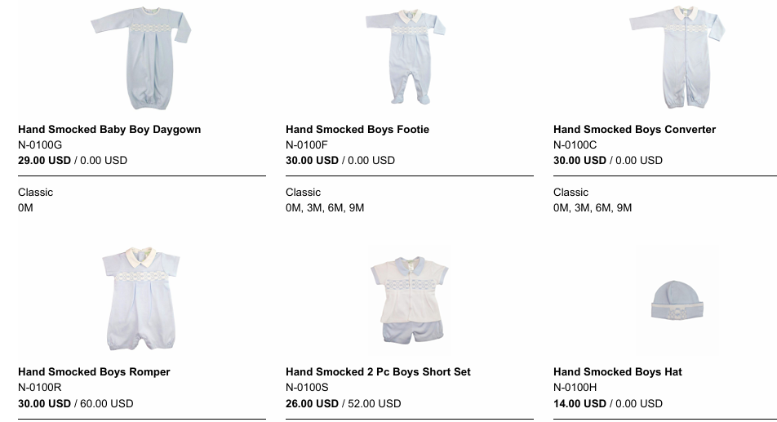

HEIRLOOM
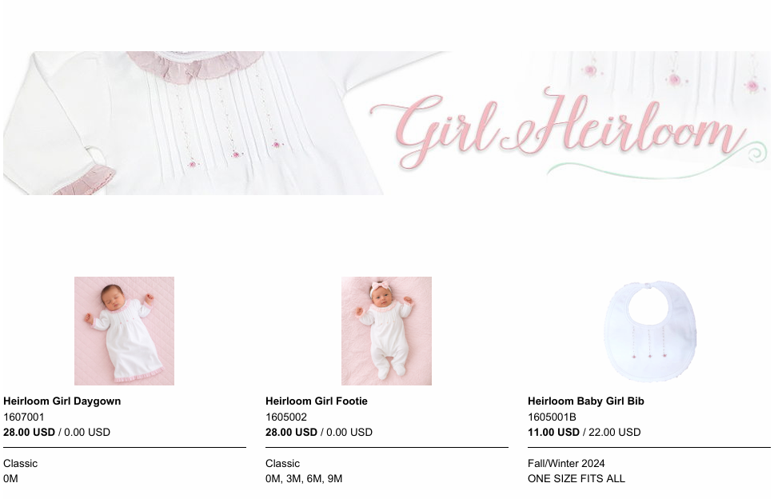
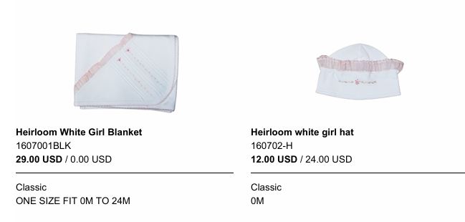
PEGGY
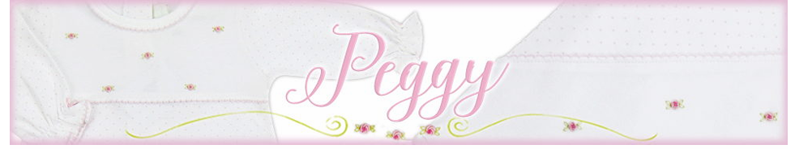
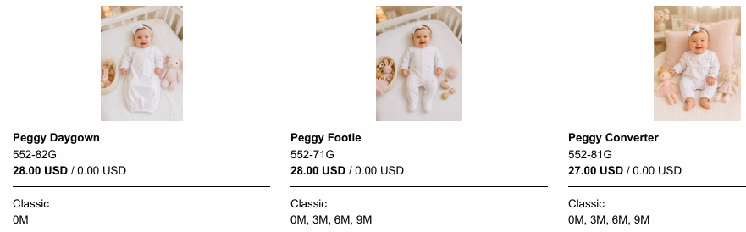
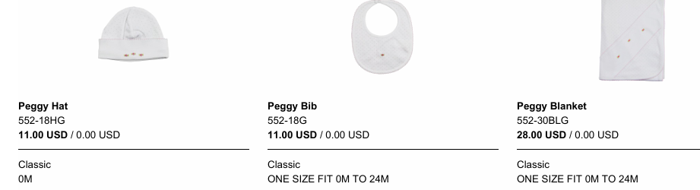
PIMA SMOCKED
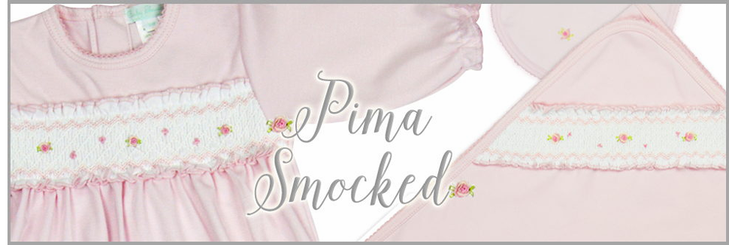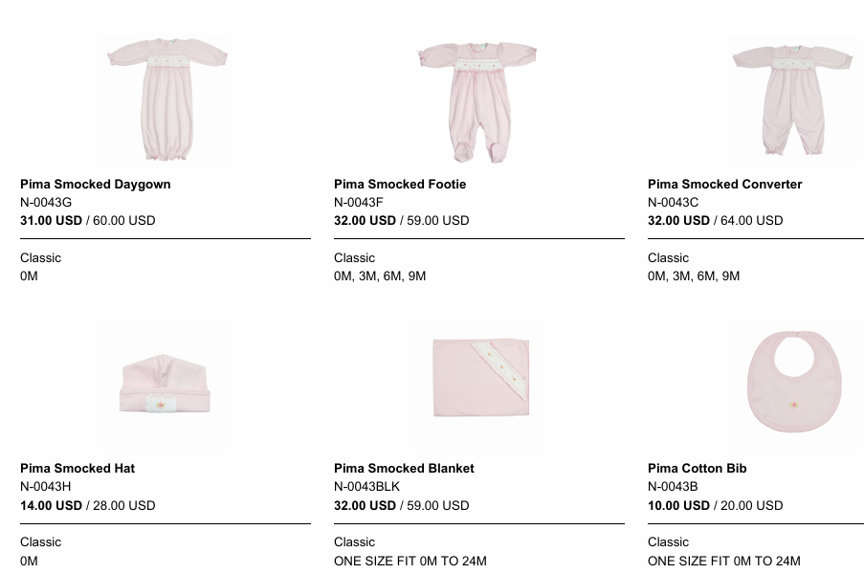
PINK DOTS
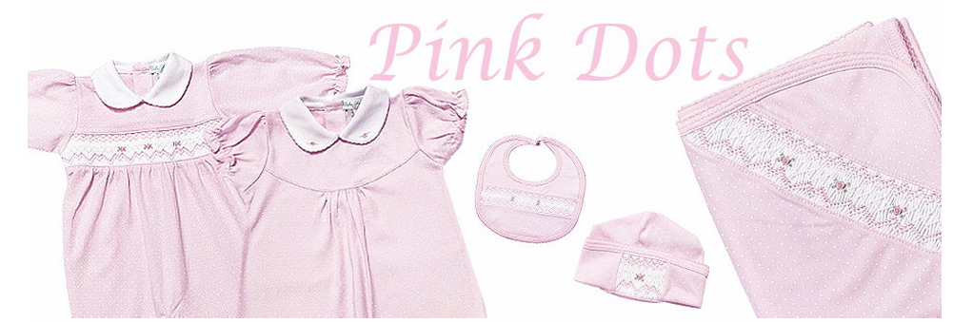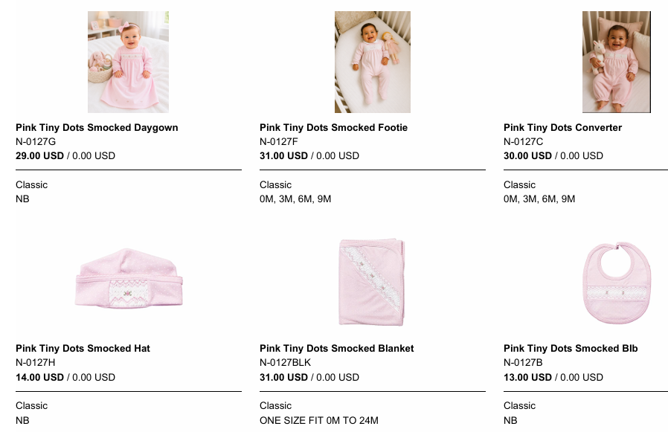
ROCKING HORSE
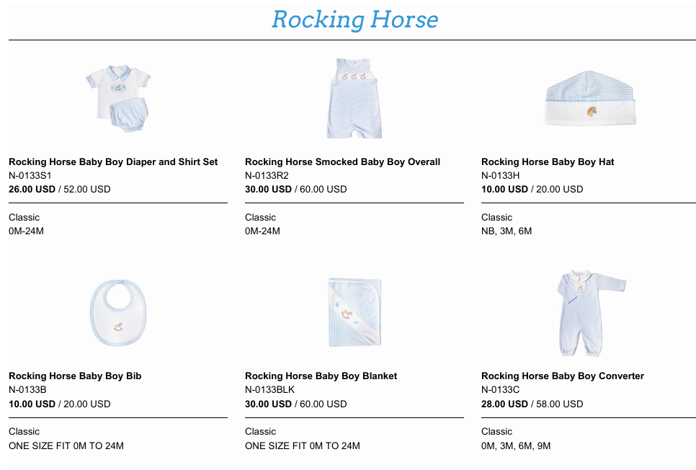
… CONTINUED…
… ROCKING HORSE CONTINUED
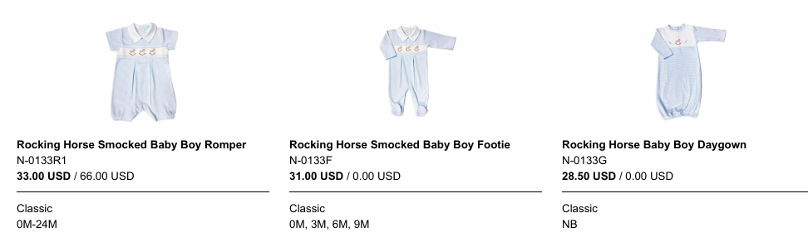

ROSE BUDS PINK
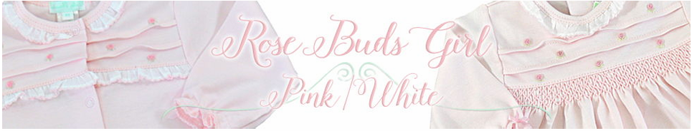
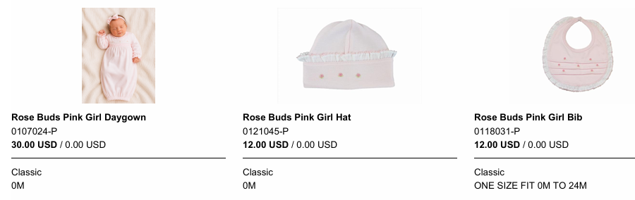
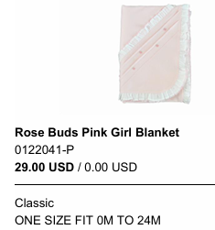
ROSE BUDS WHITE
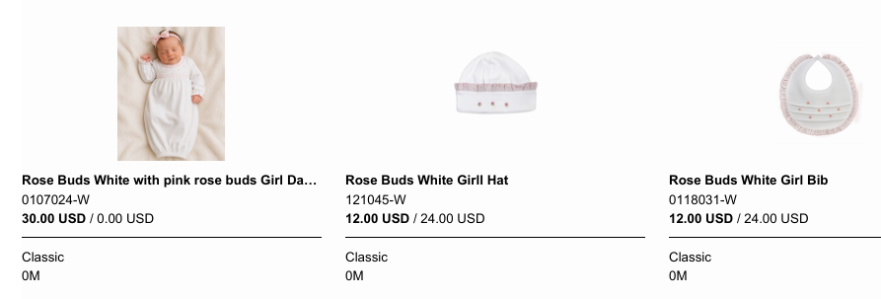
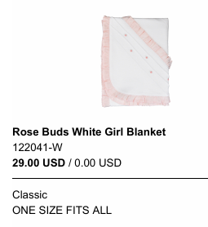
ROSE BUDS – DOTS
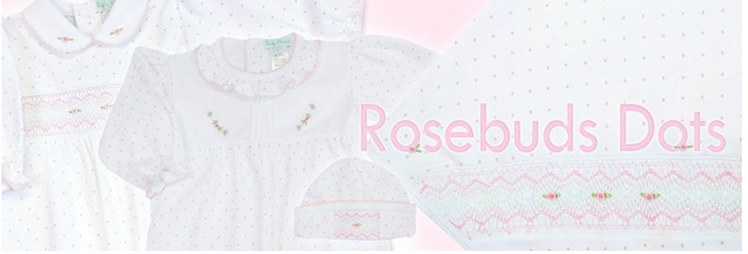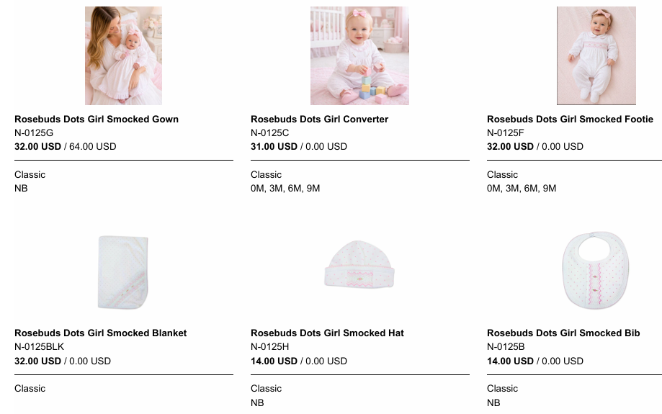
ROSES COLLECTION – PINK & WHITE
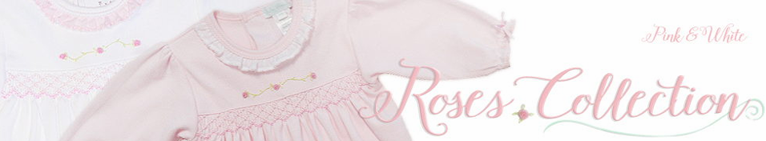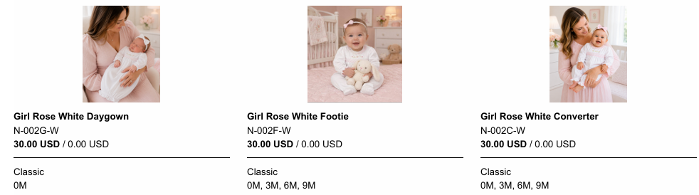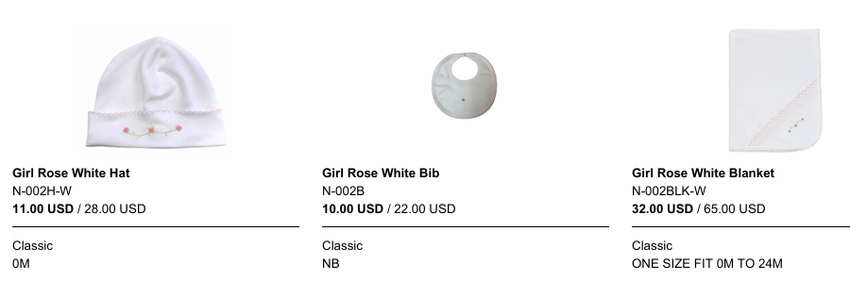
ROSEVINES
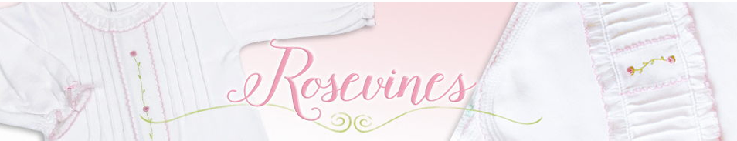
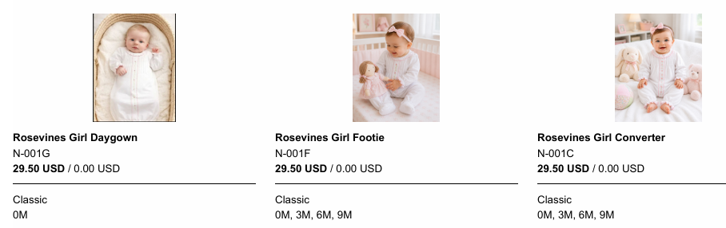
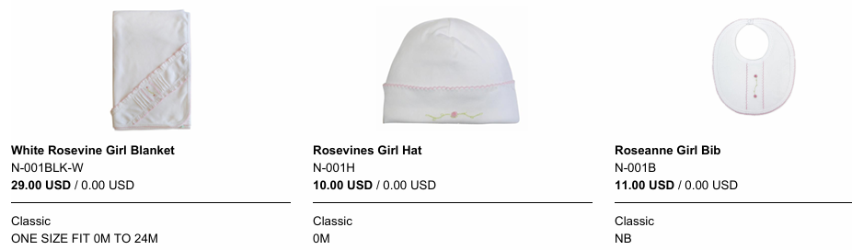
SWEET BABY BOY BLUE JACQUARD TEXTURE
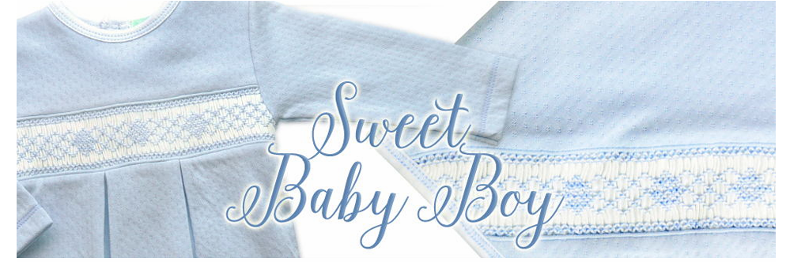
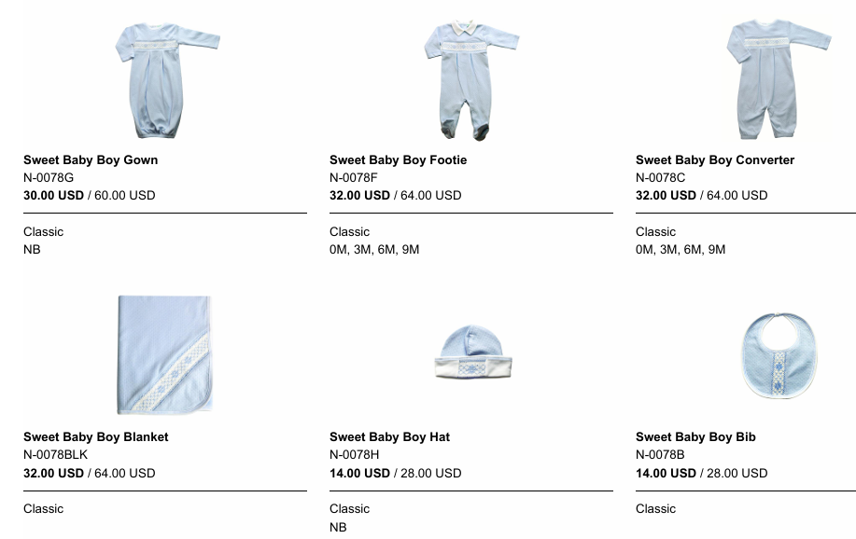

SWEET BABY GIRLS WHITE WITH PINK JACQUARD

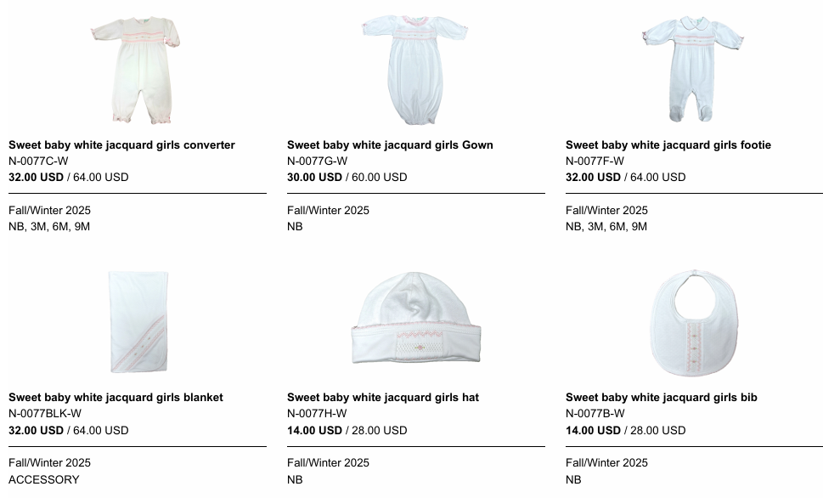

SWEET PINK
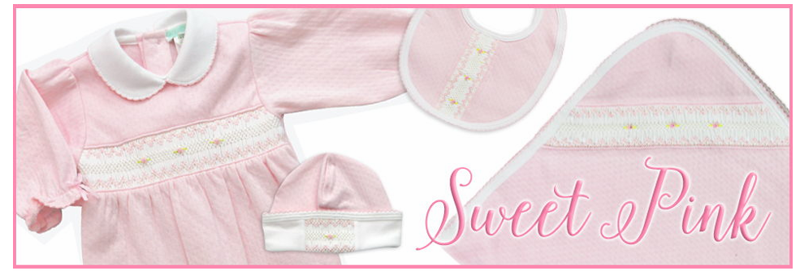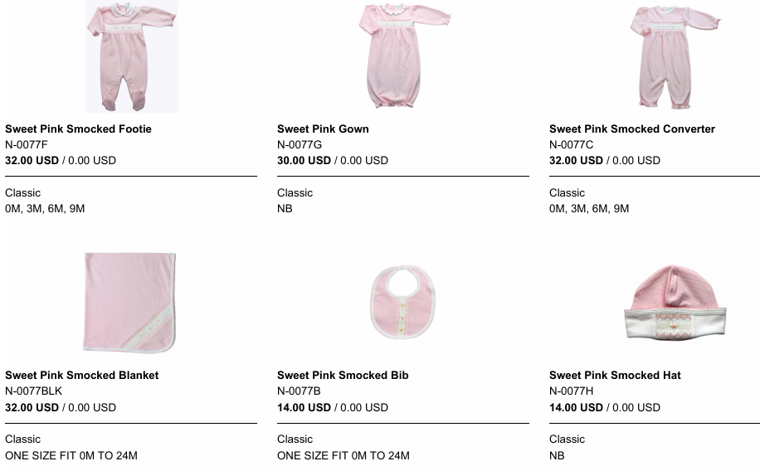
SWEET PINK DOTS
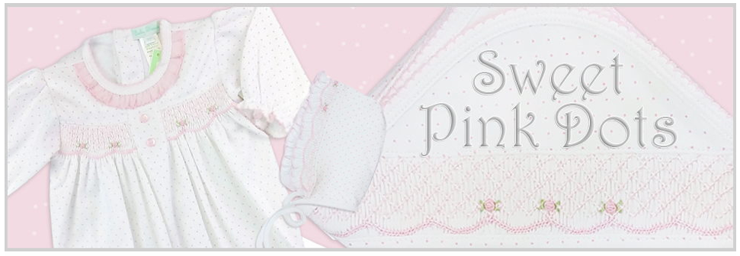
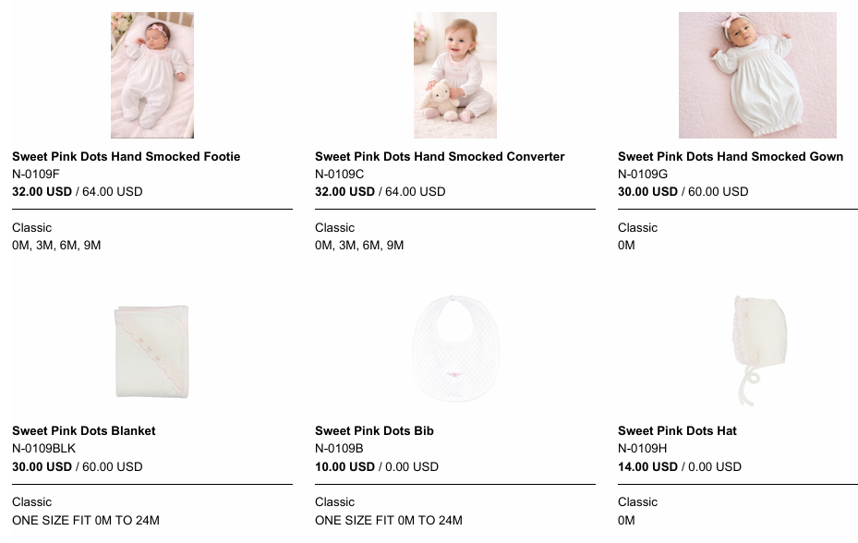
WHITE AND BLUE AND WHITE AND PINK
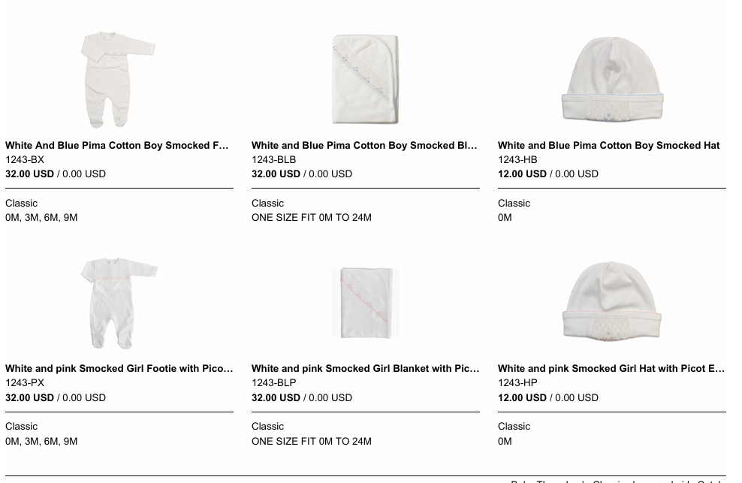

WHITE AND ECRU
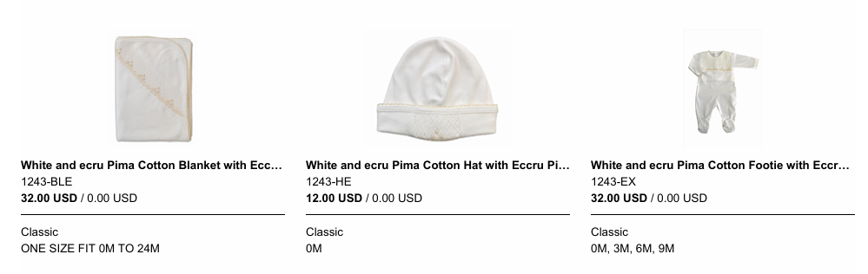
WHITE JACQUARD WITH BLUE - BOYS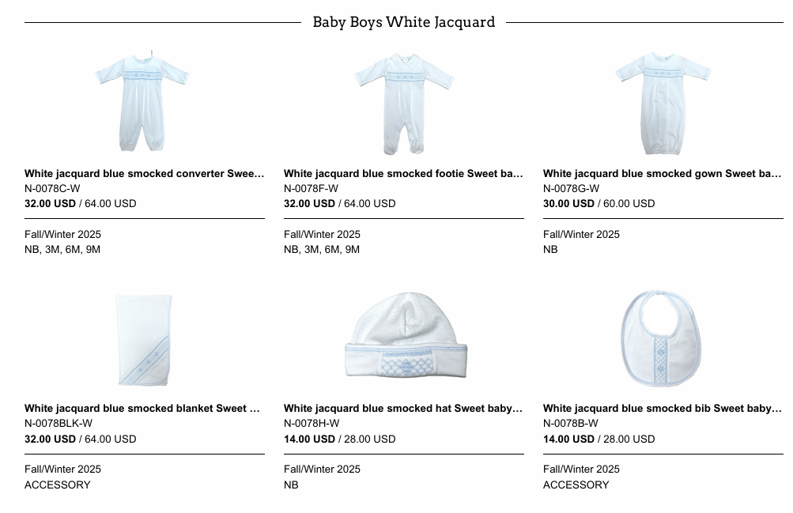

WHITE PIMA SMOCKED GIRL
