Junior

Ages 0-2

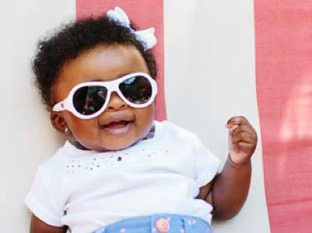

Junior Babiators sunglasses fit most babies 6 months to 2 years. Babiators are made of a soft material that is comfortable and lightweight. They are designed to fit kids’ faces and don’t pinch the temples or nose. Fit will vary by child depending on head size. If you’re between sizes, we recommend ordering your child’s sunglasses a size up.
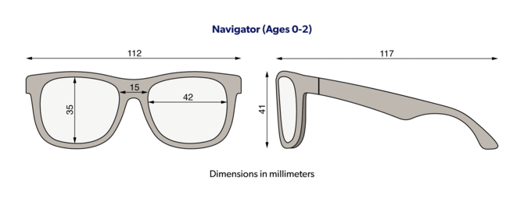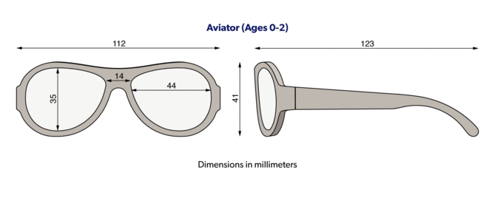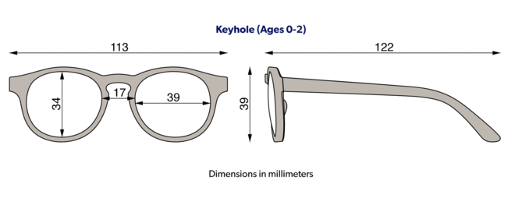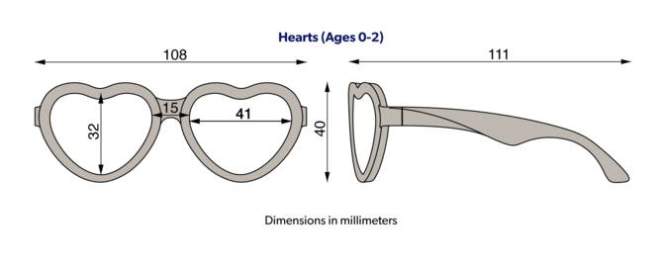

Classic

Ages 3-5

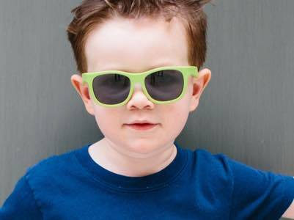

Classic Babiators sunglasses fit most children 3 to 5 years. Babiators are made of a soft material that is comfortable and lightweight. They are designed to fit kids’ faces and don’t pinch the temples or nose. Fit will vary by child depending on head size. If you’re between sizes, we recommend ordering your child’s sunglasses a size up.
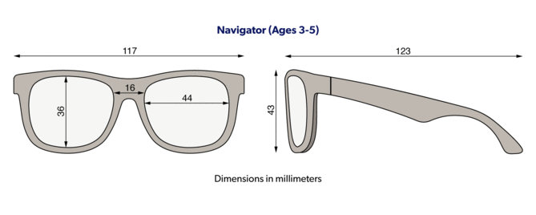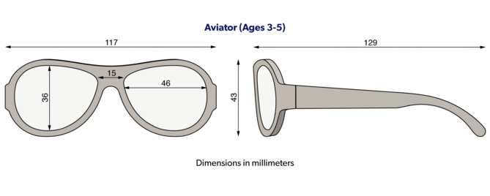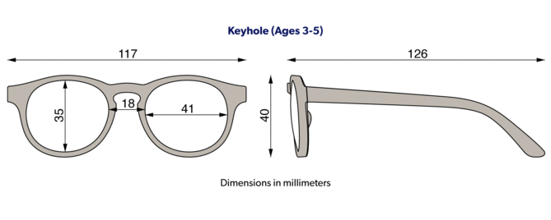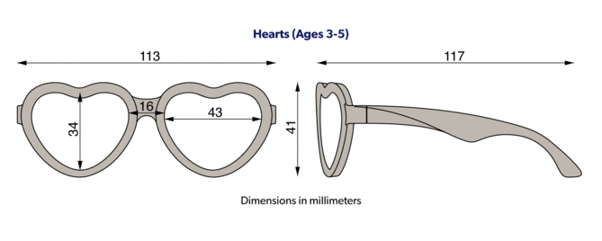

Blue Series 6+

Ages 6+

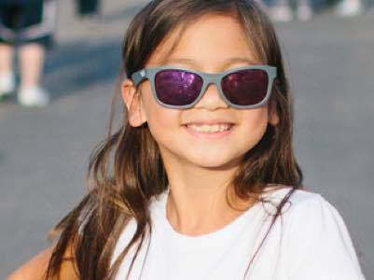

Blue Series sunglasses in size 6+ fit most school age children 6+. Blue Series are made of a soft material that is comfortable and lightweight. They are designed to fit kids’ faces and don’t pinch the temples or nose. Fit will vary by child depending on head size.
